File Text Extraction
- LangFlow
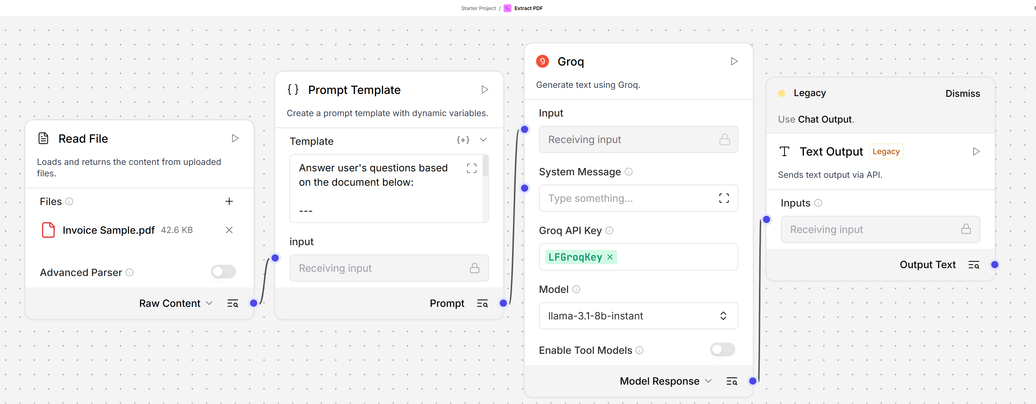
- Langflow Output – Extract all the details from the pdf such as
  - Invoice #
  - Order #
  - Invoice Date
  - Due Date
  - Total Due
PDF
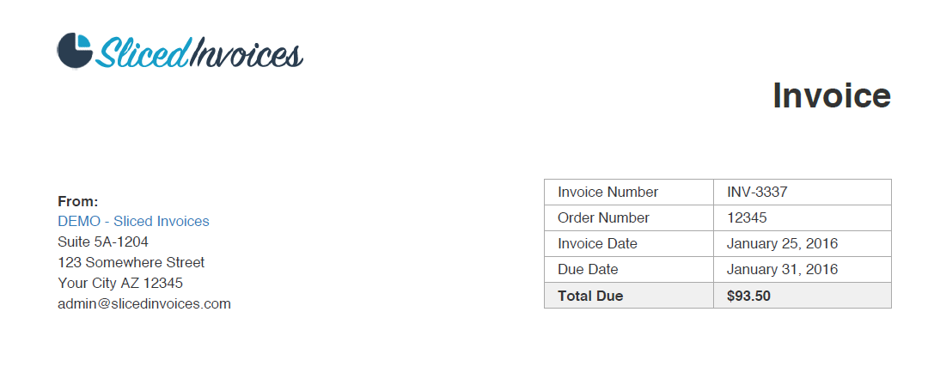
Extracted Data
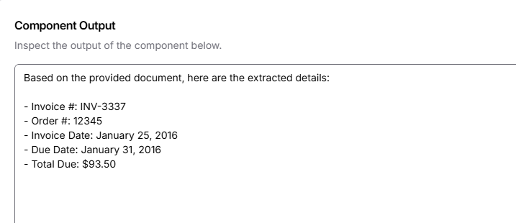

- Postman
Upload PDF
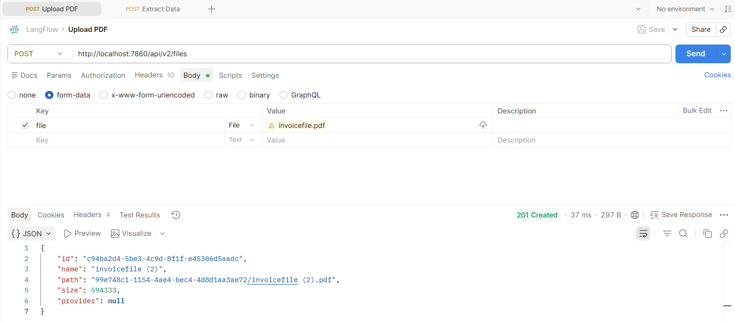
Extract Data
